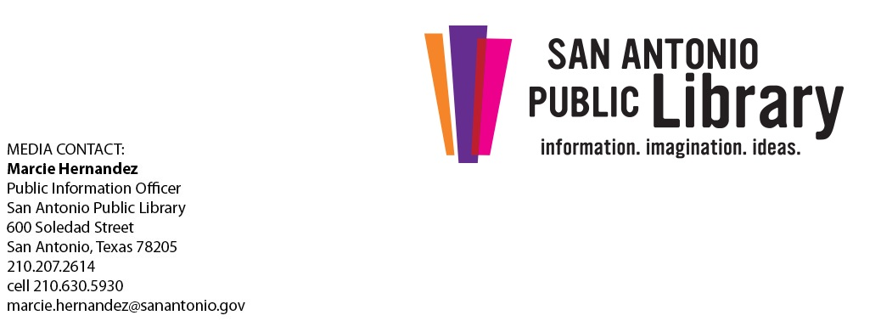
San Antonio Public Library Announces Summer Partnership with Aspergers101
Four part educational series focuses on understanding and excelling with high-functioning autism and Asperger Syndrome

WHAT: The announcement of a four-part educational summer series presented by San Antonio Public Library and Aspergers101. Aspergers101 is a local nonprofit dedicated to empowering and educating individuals with high-functioning autism and Asperger Syndrome, their advocates, and the community.

WHEN: Wednesday, May 3, 2017
10:30 a.m.

WHERE: Central Library, 2nd Floor, 600 Soledad St., 78205
Free parking in Central Library parking garage (up to 3 hours)

WHO: Jennifer Allen, Founder & CEO, Aspergers101
Ron Lucey, Executive Director, Texas Governor’s Committee for People with Disabilities

MORE: This educational series, presented by San Antonio Public Library and Aspergers101, will focus on understanding and excelling with high-functioning autism or Asperger Syndrome. A well-known team of autism experts (many of whom live successfully on the spectrum) will participate in programs that will address important related topics. A question and answer session with the panel experts will follow each program. Each program will be presented by Jennifer Allen/Aspergers101 and be held at Central Library on the second Tuesday of every month May – August from 6:30 – 7:30 p.m. They will also be live-streamed via Sinclair Broadcasting at News4SA.com/Live/Event and shared remotely at six participating Library locations: Cortez, Parman, Cody, Mission, Potranco, and Guerra branch libraries.
Panel experts include Dr. Ghia Edwards, Psy.D. Behaviorist; Dema K. Stout, MA, PCC, CPCC, Greatness Coaching; Janet Enriquez, Autism Education Specialist, Region 20; Dr. Berenice de la Cruz, Ph.D., BCBA-D, Chief Operating Officer, Autism
Community Network; and Dr. Louise O’Donnell, Ph.D., Assistant Professor of Psychiatry, UT Health Science Center.
Visit bit.ly/Aspergers101for a complete list of programs and streaming locations or call 210-207-2500.
- ### -

The San Antonio Public Library: changing lives through the power of information, imagination, and ideas.
For more than 110 years, the award-winning San Antonio Public Library has been a vital center for free learning, knowledge, communication, culture and enjoyment for the whole community. With a world-class Central Library, 26 locations throughout the city, a Library portal at the Briscoe Western Art Museum, and an extensive collection of e-books and online resources, the San Antonio Public Library is as close as around the corner, the nearest computer or smartphone. For more information, visit mysapl.org. Be sure to like us on Facebook at The-San-Antonio-Public-Library and follow us on Twitter @mysapl.
Powered Libraries is a TLA Campaign that seeks to raise support and awareness of the role of libraries. Read more about the history of the campaign and its key messages, objectives, and goals.

One San Antonio
Diverse, internationally connected and globally competitive, San Antonio has a vibrant culture and economy and is consistently ranked among the fastest-growing cities in the United States. America’s seventh-largest city offers opportunities in industries ranging from bioscience, financial services, aerospace, cybersecurity, energy and transportation manufacturing to healthcare. In 2016, San Antonio was named an All-America City by the National Civic League. We are “Military City USA,” home to crucial military commands supported by a patriotic citizenry. We welcome 32.5 million visitors annually who inject $13.4 billion annually into our economy, and UNESCO recently designated the city’s Spanish colonial missions as a World Heritage Site. Celebrating its 300th anniversary in 2018, San Antonio is a city with a storied past and an even brighter future. For more information, visit www.sanantonio.gov.

